**Name of the Project:** Phase-2 Project [FlyAway Protal]

**Problem Statement:** As a Full Stack Developer, design and develop an airline booking portal named as FlyAway.

**Objective:** Create pages and connect them to backend for flawless user experience and seamless flight booking.

**Product capabilities:**

**User features:**

1. User login with backend verification: userLogin table in mySQL has 6 entries for already registered users. Every login from a user will verify the inputs with the back end and then will be taken forward. If the entered password is incorrect user will be taken back to login page for re-entering.(Files: Userlogin.jsp, verifyUserLogin.jsp)

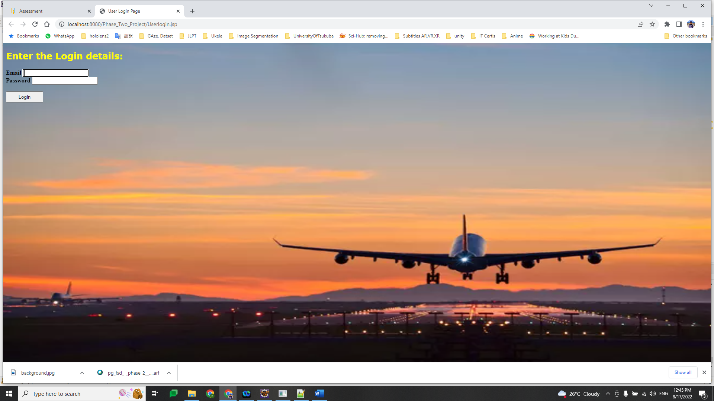 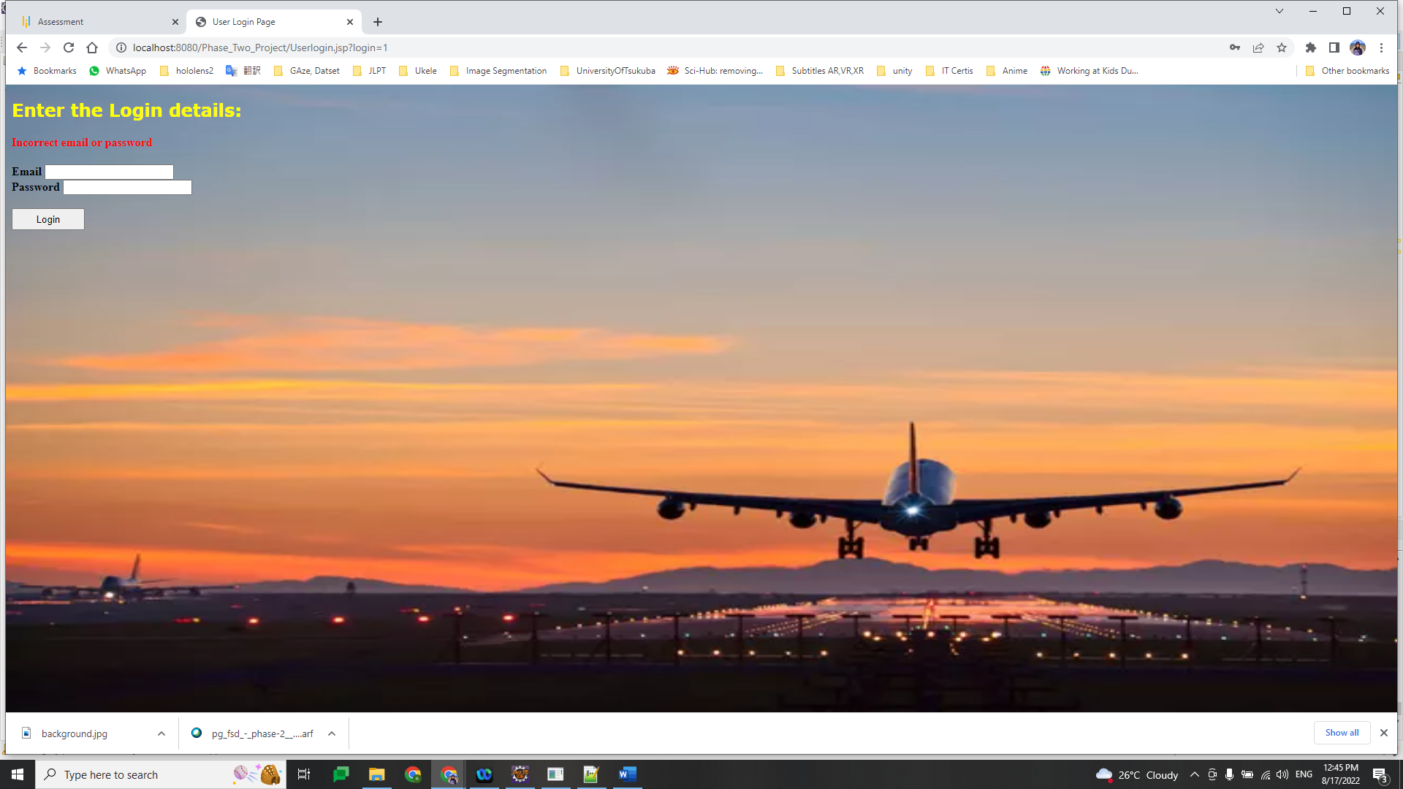

1. Searching for desired Flights: The page will allow user to enter flight search details like: date of travel, source city, destination city and number of travelers. Based on the inputs the database will be queried (table: flightdetails) and desired flights will be displayed. User can choose a desired flight from the list by clicking on the flight no. (Files: searchflight.jsp, flightpage.jsp)

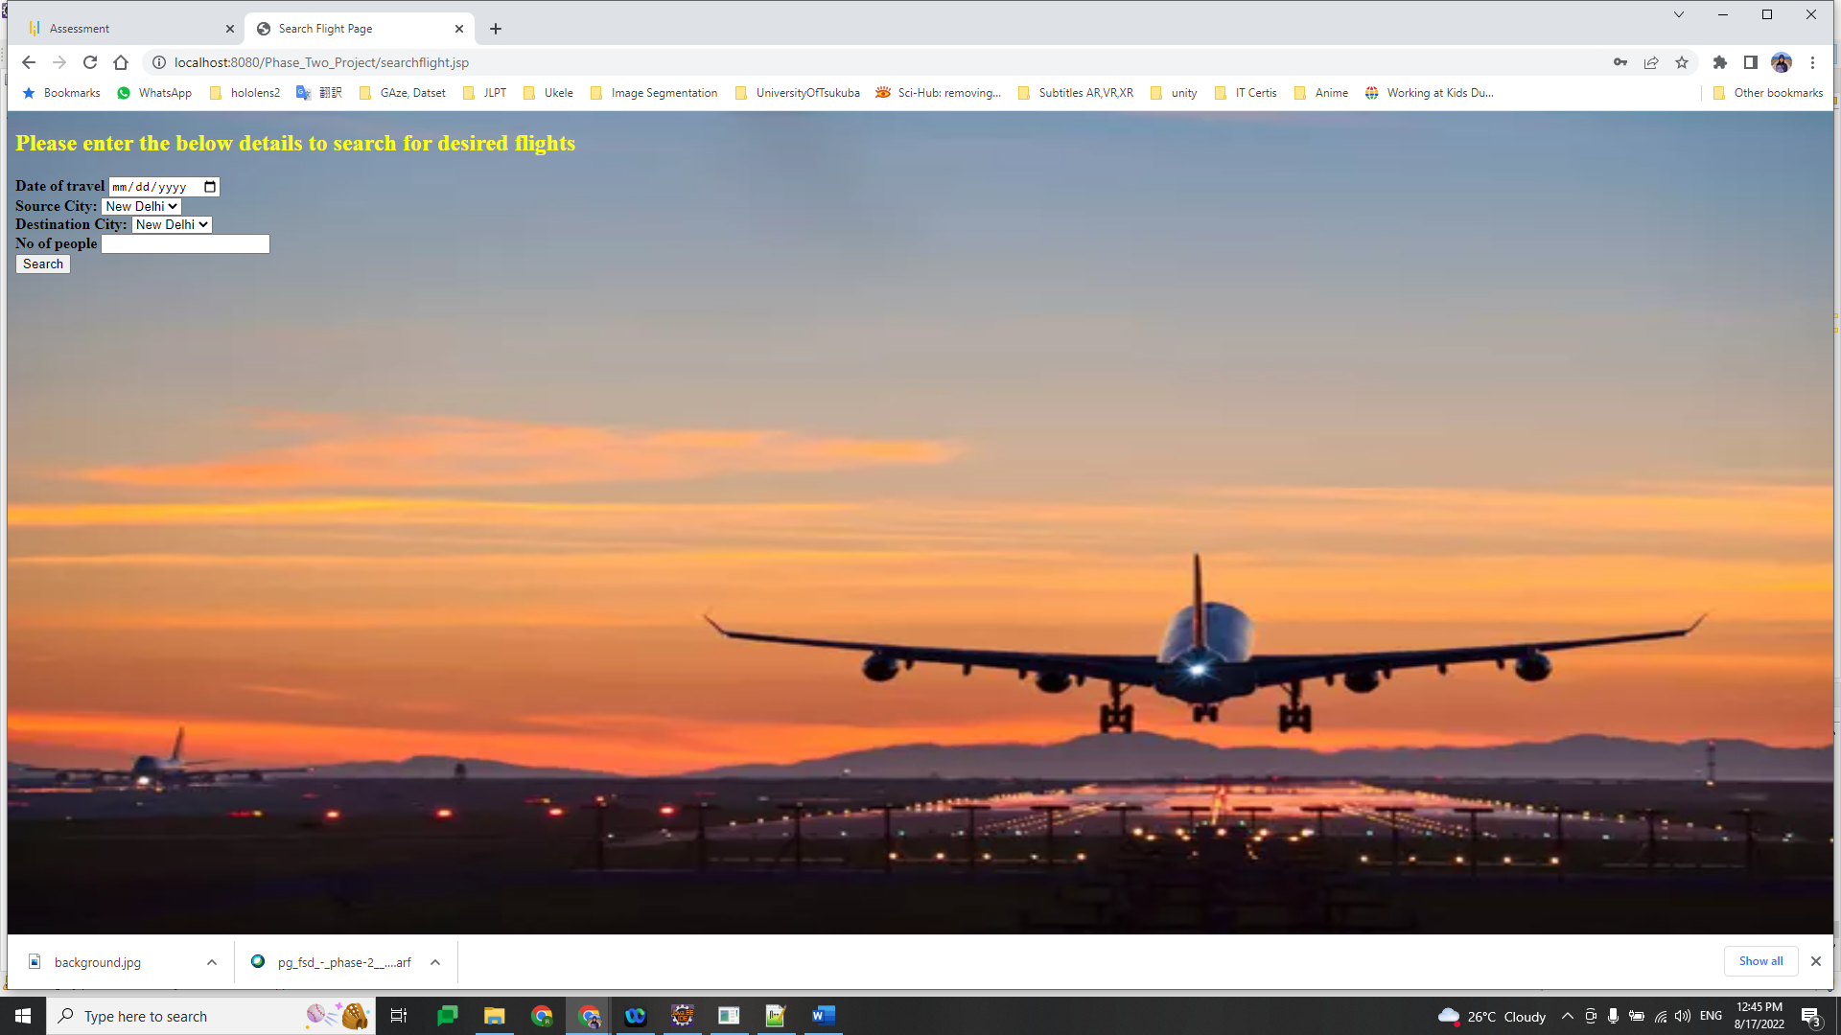

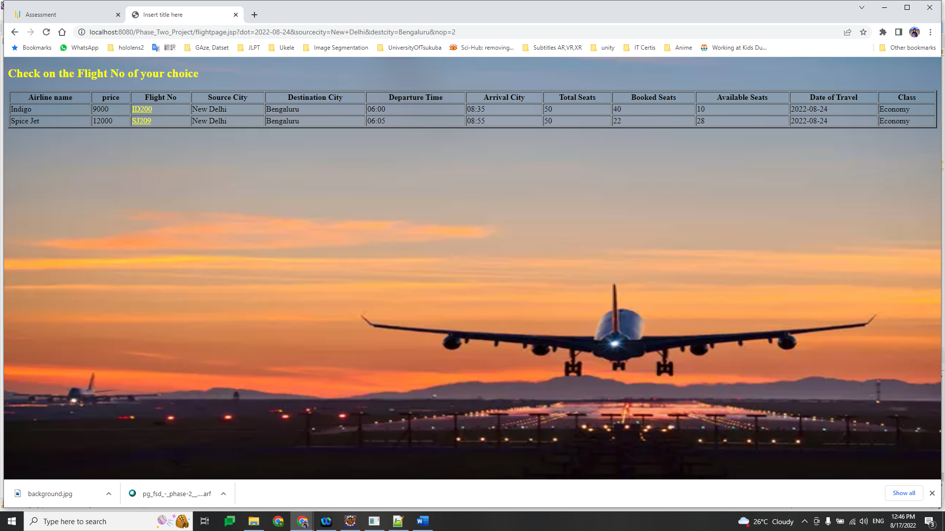

1. User registration: Once the desired flights are selected the used will be entering personal details. Once the details are filled the user will be taken to the review page where the user can verify the information. The user can also click on the “Edit” button to re-write the details.(Files: registerdetails.jsp, reviewdetails.jsp)

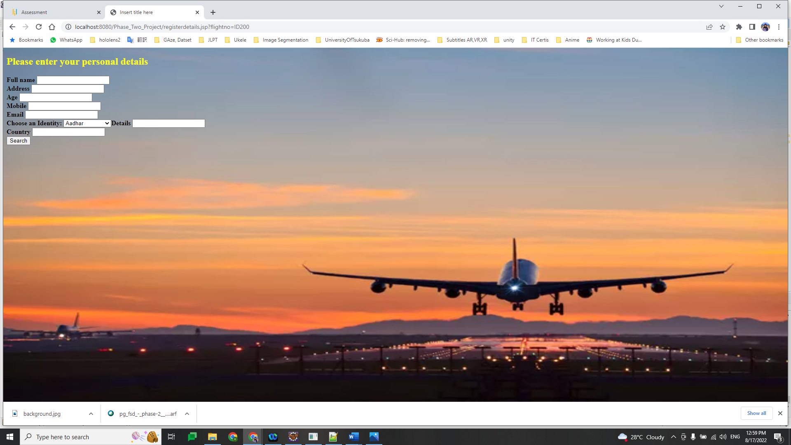

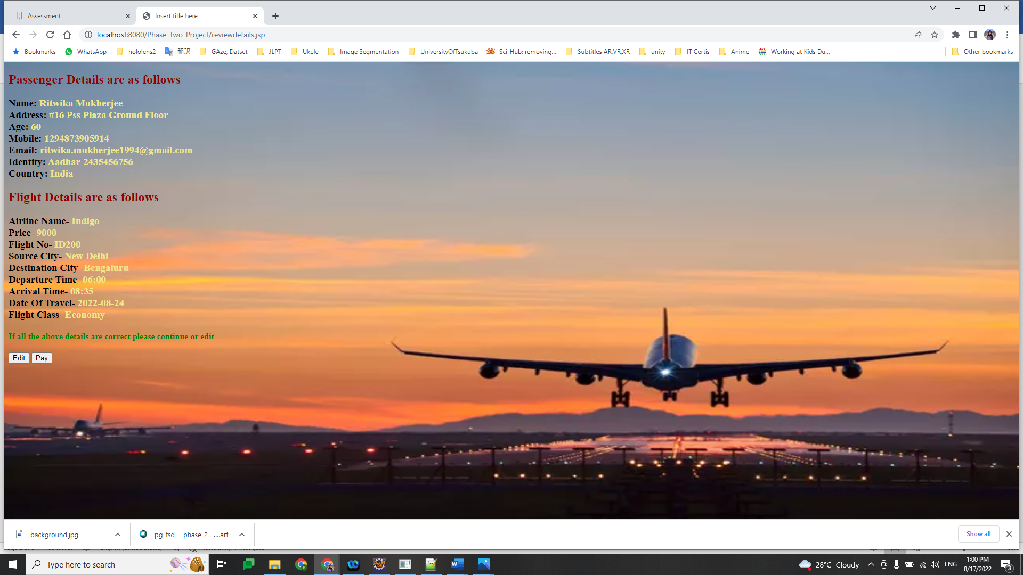

1. Payment: Once the details are reviewed the used will be taken to the Payment portal to make the final payment. During this process all the user details will be uploaded to the database (table: registerDetails). After successful payment confirmation will be shown.(Files: Payment.jsp, confirmation.jsp)

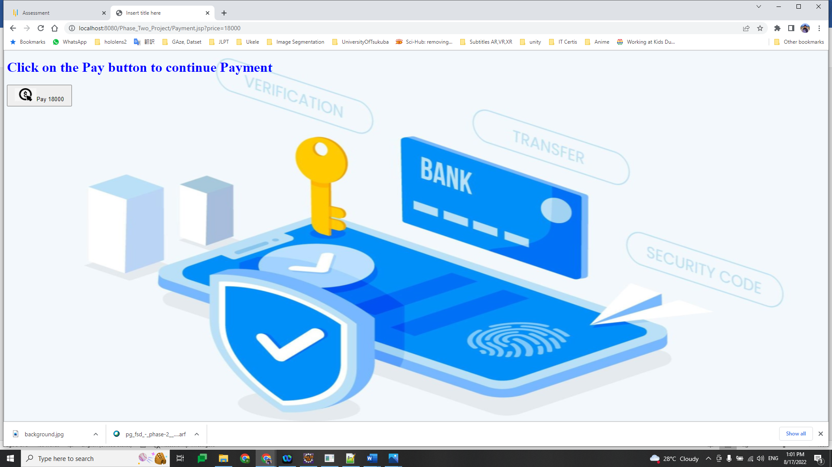

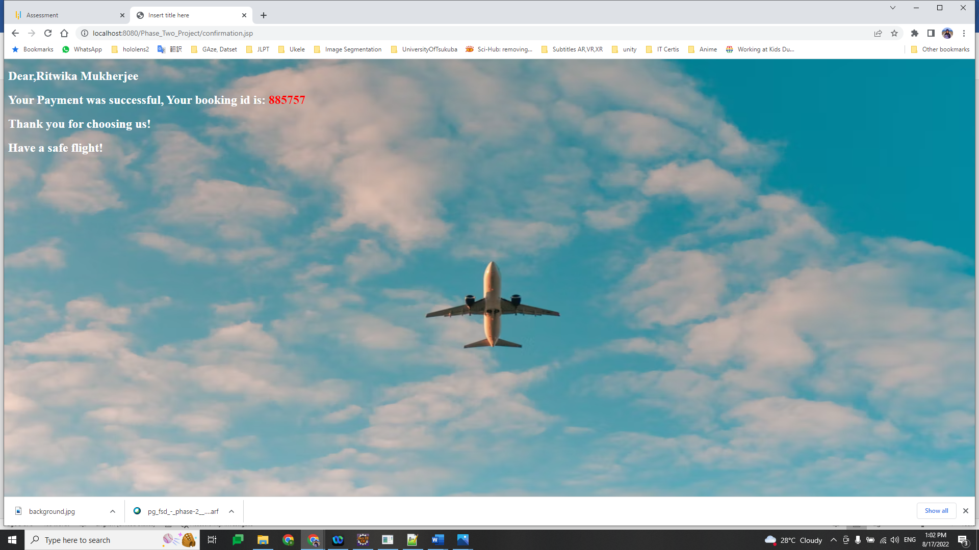

Admin features:

1. Admin Login: Admin login also has a similar login verification as the user login.

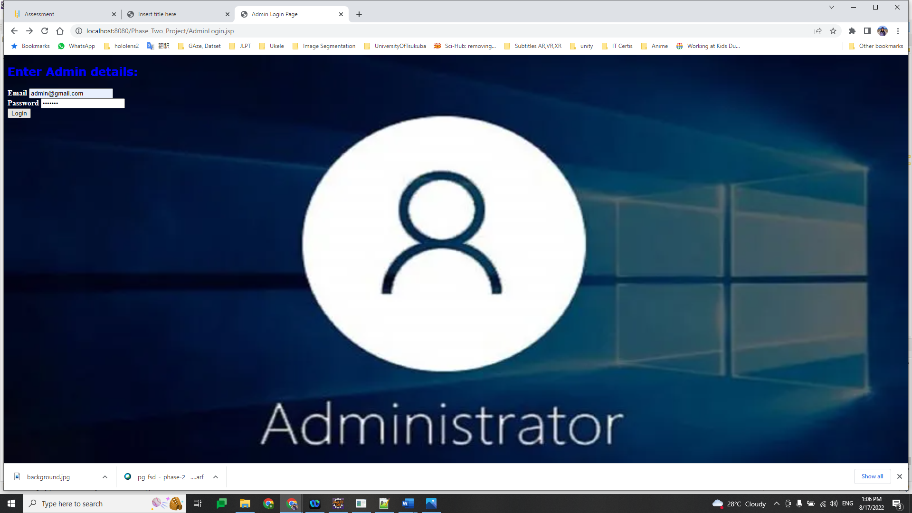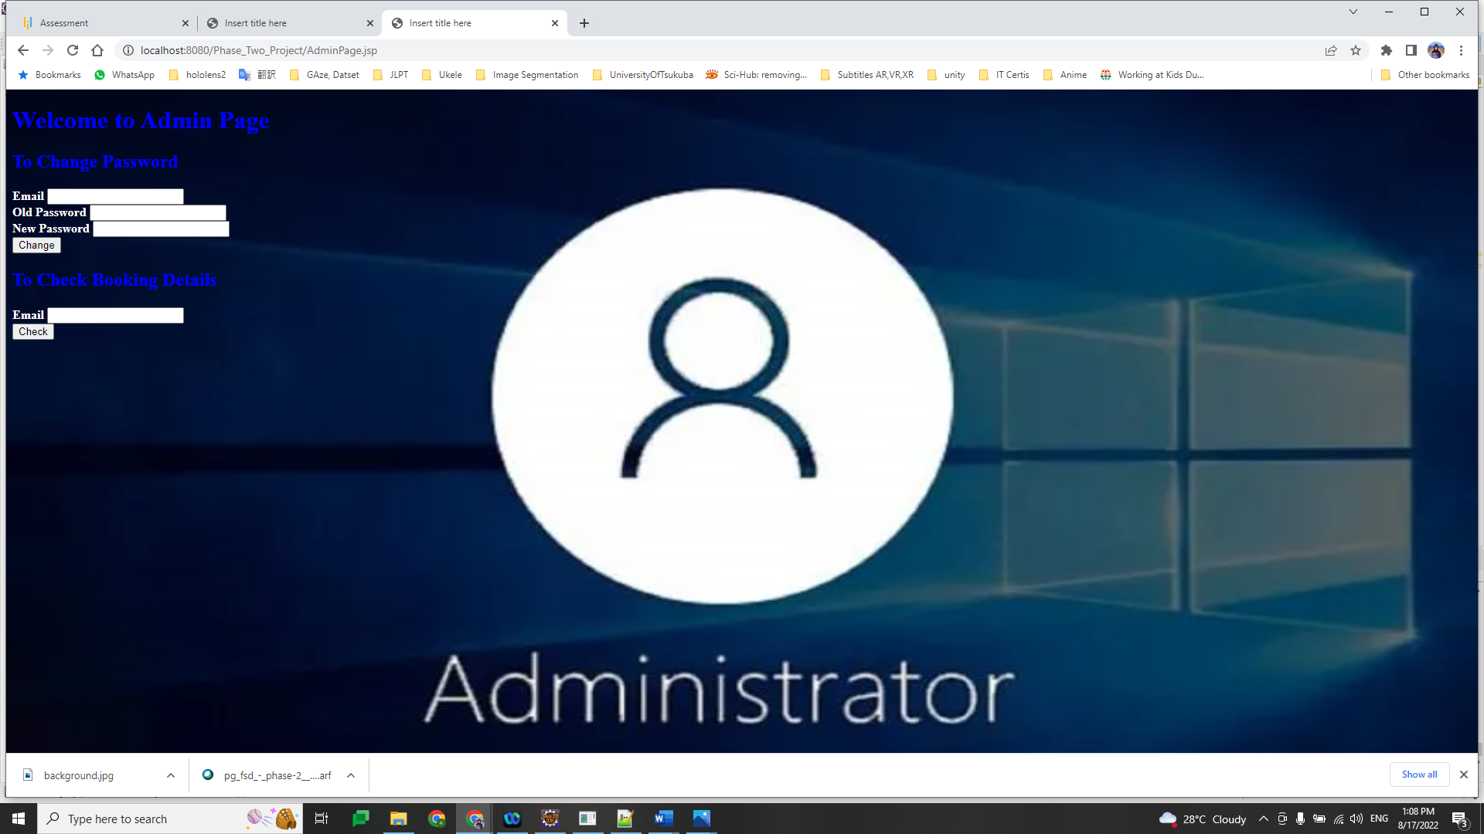

1. Update Password: The admin page consists for options to update the existing password.

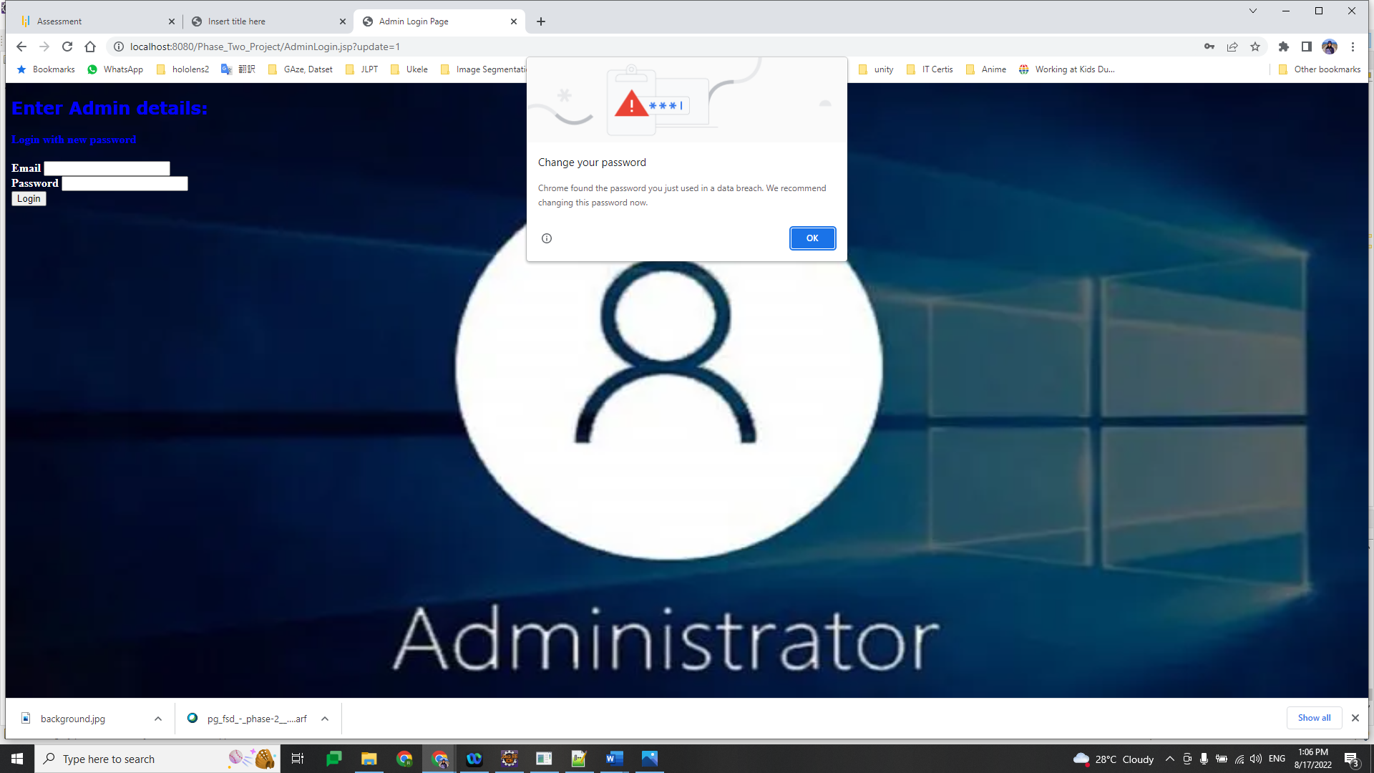

1. Checking booking history: The admin can enter an user email id to checking the booking history.

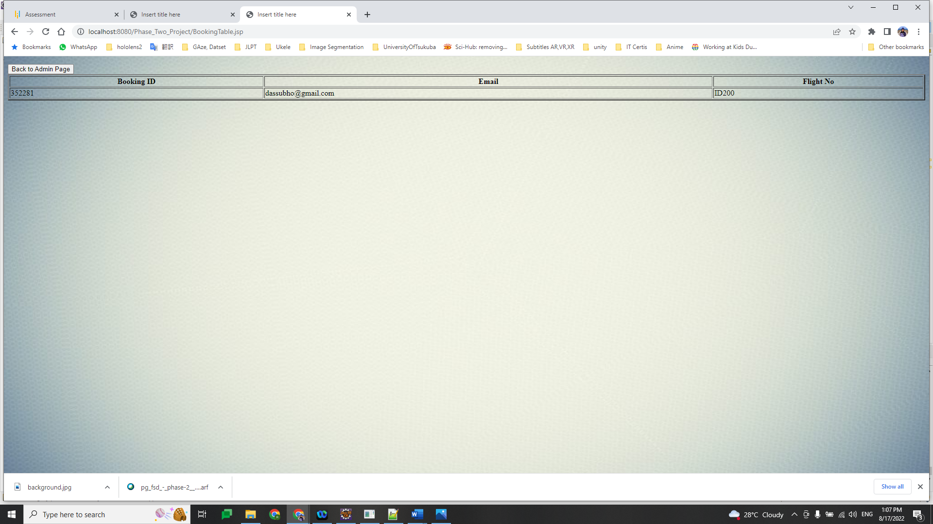

**Database Tables:**

1. **User Login:**

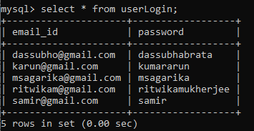

1. **Admin Login:**

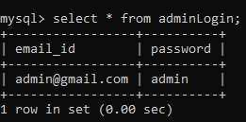

1. **Flight Details:**

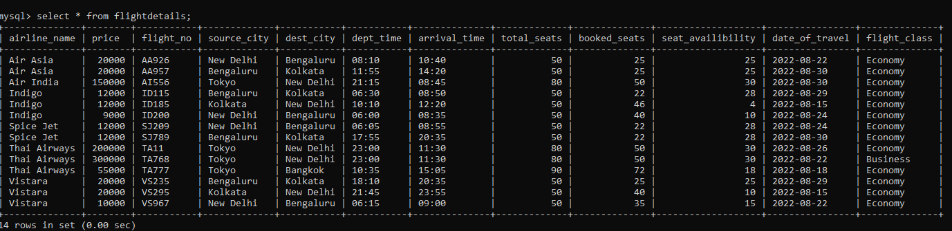

1. **User Registration Details:**

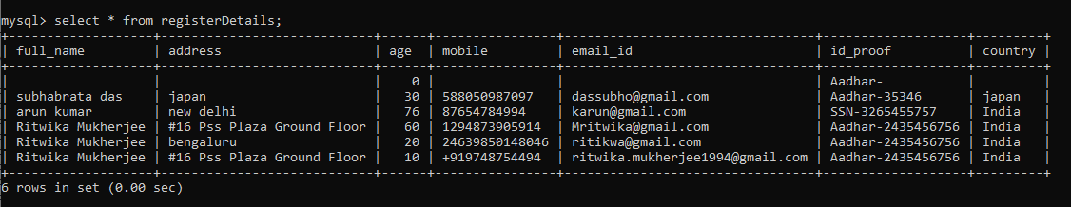

1. **Booking Details:**

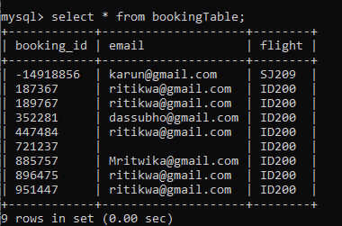

**Sprint Planning Details:**

No of Sprints: 2

No of User Stories: 6

No of tasks: 12

Tasks are as follows:

1. Created user login page and admin login .
2. Created database tables: userLogin, adminLogin, flightdetails, registerDetails, bookingTable,
3. Added user verification functionality using created tables.
4. Added flight search page.
5. Queried database to match user requirement and display them.
6. Added your registration page.
7. Added review details page to show user’s personal details and selected flight details.
8. Added payment page and created button design, Confirmation page to show few details.
9. Admin page functionality.
10. Update password functionality.
11. Booking table query based on email.
12. Design and user interface restructuring.

**Flow Chart of the application:** 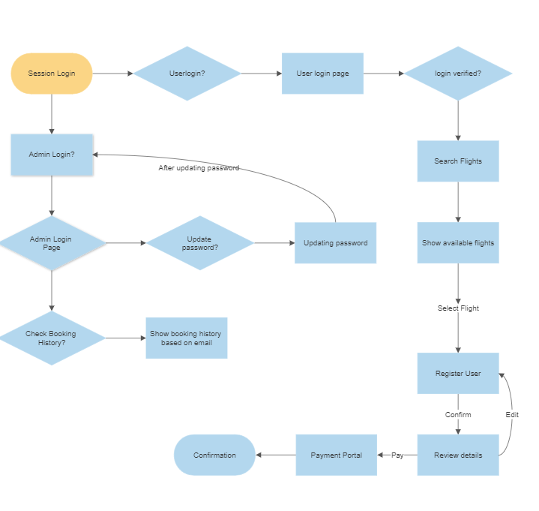

**List of the core concepts used are as follows:**

1. MySQL
2. Exception handling
3. JSP(jstl tags, core tags, html, sql tags)
4. Code optimization.

**GitHub Link for the course code:** https://github.com/ritwikam2020/Phase-Two-Project